Asia Sunday 2020 – Worship Resources
‘God, Heal Us as We are Vulnerable’

Introduction

The world is facing an unprecedented situation today due to the spread of the novel coronavirus (COVID-19). The outbreak of COVID-19 is as a loud wake-up call for all countries on our planet. The proliferation of COVID-19 as well as other major epidemics such as SARS, Ebola, Nipah, and MERS since the beginning of this century have shattered several myths about threats arising from new pathogens and diseases that escalate as epidemics. The eruption of these epidemics have proved that such diseases are no longer limited only to densely-populated poor countries, and that wealthy, developed countries are not immune to them. Dependence on higher levels of living standards and apparently well-developed health care systems alone cannot be our sole solution to overcome new pathogens and epidemic-prone diseases.

The emergence of new diseases and the spread of virulent strains are a result of systemic practices and actions by which we exploit the planet and destroy God’s creation. The rapid spreading of viruses and institutional delays in global responses have proved that even sophisticated healthcare systems are not sufficiently equipped to mitigate the damage caused. The spread of COVID-19 has exposed the inadequacy and lack of proper health care management mechanisms and has pushed humankind to the brink of vulnerability.

The gravity of the multiplication of COVID-19 and its varied impacts on many countries are unimaginable and have not yet been properly quantified. A large number of people around the globe are extremely susceptible. In the span of a few months since the end of December 2019, the total number of confirmed cases has now surpassed 128,000 people in 126 countries worldwide, with over 4,717 deaths reported so far. As of now, people in 25 countries and regions in Asia have been affected by this deadly virus. The crucial conditions which we are currently collectively undergoing is also a reminder for humankind to reflect on the fragility of human life and the ultimate vulnerability of the entire cosmos! Our world needs prayers, cure, and healing especially in the times of this crisis. The Christian Conference of Asia (CCA), in this context, has decided to focus on the theme, God, Heal Us as We are Vulnerable for Asia Sunday 2020.

We encourage all member churches and councils of CCA as well as the ecumenical partners and churches around the world to use this special liturgy in the coming days for their prayers and also on 24 May 2020, which is when Asia Sunday will be observed. As we continue to have faith and trust in God’s love for humankind and divine power to heal, let us continue to pray for health, recovery, and healing. May God hear our prayers, and heal all those who are suffering from illness at times of vulnerability.

Heal us, O Lord, and we shall be healed, save us and we shall be saved, for you are our praise.
(Jeremiah 17:14)

Mathews George Chunakara
General Secretary, CCA
Call to Worship

We come to worship God at this time of our vulnerability. As we face an unprecedented threat to not just our well-being but our very survival, let us pray together to our Almighty God and strengthen our faith.
We believe, “the prayer of faith will save the sick, and the Lord will raise them up.” (James 5:15)

- Give Us Light

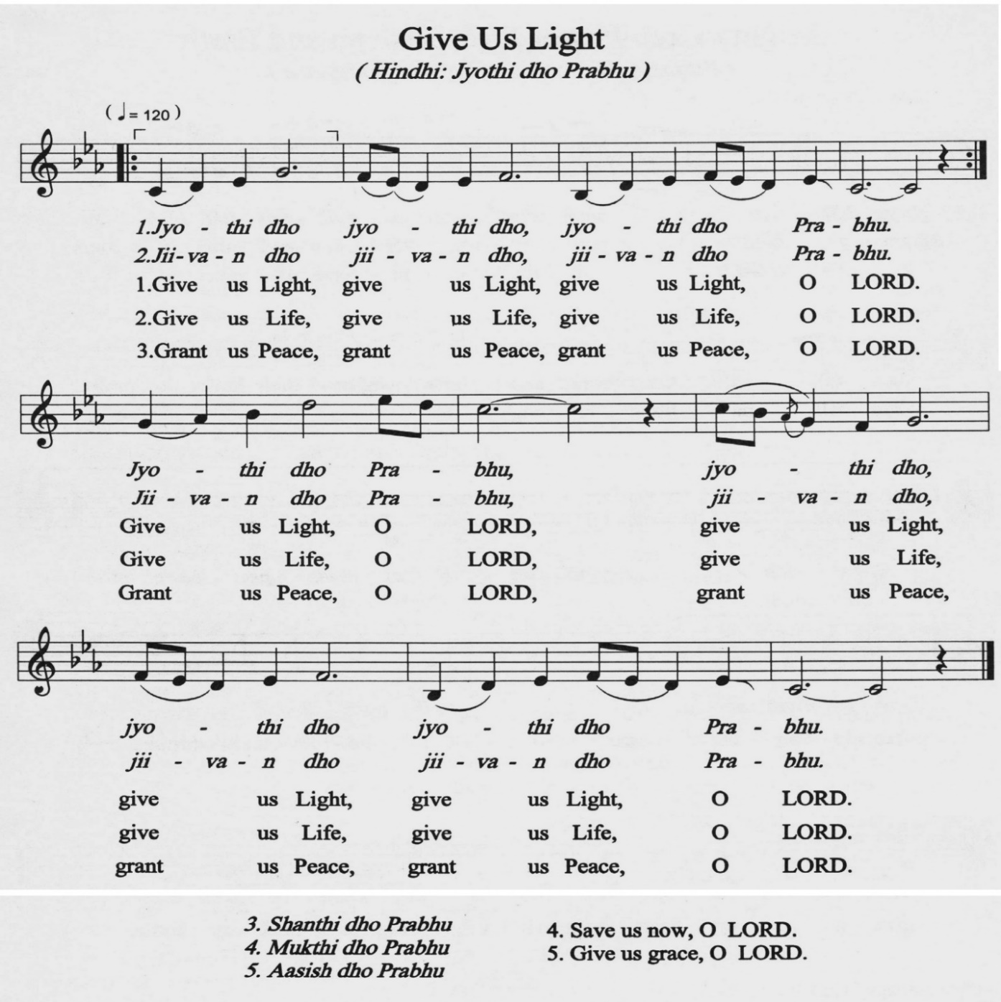

Reading of Psalms 41 (NRSV)

Happy are those who consider the poor;
The Lord delivers them in the day of trouble.
The Lord protects them and keeps them alive;
They are called happy in the land.
You do not give them up to the will of their enemies.
The Lord sustains them on their sickbed;
In their illness, you heal all their infirmities.
As for me, I said, “O Lord, be gracious to me; heal me, for I have sinned against you.”

Lamentation

In faith we come before you, asking for mercy and forgiveness for our sins against you and your creation.
In this time of anxiety and distress, we lift up to you the COVID-19 situation throughout the world.
At this time of our fragility, fear, and death, we cry out to you.
Heal our sick, console those who are bereaved, protect those who care for us.
We lift our prayer to you Lord, and trust in your infinite mercy.

God, have mercy on us and hear our prayer, Lord; listen to our cry for help.
God, hear the cry of our bodies. In your mercy, you heal those suffering in body, mind, or spirit. We cry out to you now on behalf of those infected by the virus. Heal the sick and bind up the broken-hearted who grieve those felled by this illness.

God, have mercy on us and hear our prayer, Lord; listen to our cry for help.

God, we are weak and vulnerable. When you walk with us, you spread your healing power. We place in your loving care our people affected by the virus. From the marshes of fear and death, we cry out to you. Keep us strong in faith, hope, and love.

God, have mercy on us and hear our prayer, Lord; listen to our cry for help.

Assurance

I am going to bring it recovery and healing; I will heal them and reveal to them abundance of prosperity and security. I will restore the fortunes of Judah and the fortunes of Israel, and rebuild them as they were at first. (Jeremiah 33:6-7, NRSV)

God the Creator brings us new life; God forgives and redeems us.
In the life, death, and resurrection of Jesus, we are assured that there is no sin so terrible that God cannot forgive, no hurt so terrible that God cannot heal.

Amen, Amen. Thanks be to God.

Scripture Reading

1 Kings 8:37-40 (NRSV)

³⁷ “If there is famine in the land, if there is plague, blight, mildew, locust, or caterpillar; if their enemy besieges them in any of their cities; whatever plague, whatever sickness there is; ³⁸ whatever prayer, whatever plea there is from any individual or from all your people Israel, all knowing the afflictions of their own hearts so that they stretch out their hands towards this house; ³⁹ then hear in heaven your dwelling place, forgive, act, and render to all whose hearts you know—according to all their ways, for only you know what is in every human heart—⁴⁰ so that they may fear you all the days that they live in the land that you gave to our ancestors.”

Mark 1:29-34 (NRSV)

²⁹ As soon as they left the synagogue, they entered the house of Simon and Andrew, with James and John. ³⁰ Now Simon’s mother-in-law was in bed with a fever, and they told him about her at once. ³¹ He came and took her by the hand and lifted her up. Then the fever left her, and she began to serve them. ³² That evening, at sunset, they brought to him all who were sick or possessed with demons. ³³ And the whole city was gathered around the door. ³⁴ And he cured many who were sick with various diseases, and cast out many demons; and he would not permit the demons to speak, because they knew him.

- Comfort, Comfort All My People

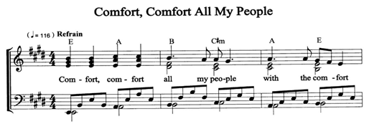
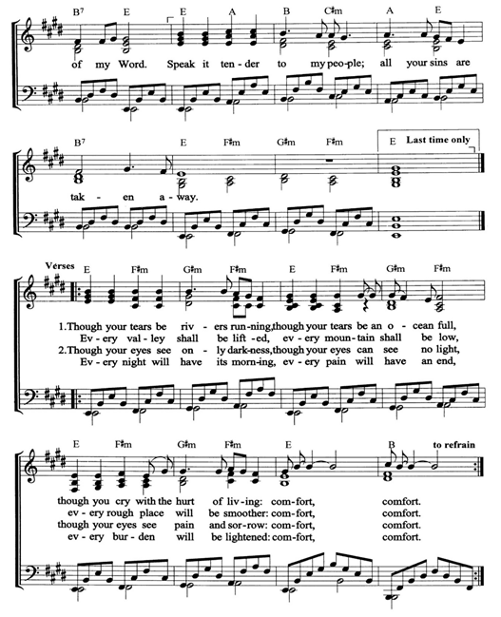

Biblical Reflection/Sermon

Intercessory Prayer

Bless the Lord, O my soul, let all that is within me, bless his holy name, for he forgives all your sins and heals all your diseases. (Psalm 103:1, 3)
God, we pray for all those who are suffering from the spread of COVID-19, and we beseech your healing touch that they may receive care in their time of need.

We pray for those in sickness, bringing them to you who understand people’s fear and pain before they speak of them. Surround the frightened with your tenderness, give strength to those in pain, hold the weak in your arms of love, and give hope and patience to those who are recovering.

God, in your mercy, heal them as they are vulnerable.

God, we are intimately interconnected no matter where we reside on the earth. We pray for all those who are affected in different parts of the world; and so we plead for healing, good health care, relief, and wholeness for all God’s people in all the places where this virus has made its appearance. May God grant the afflicted the strength and courage to sustain their faith and hope, and continue their fight against the epidemic. May our collective care, effort, resources, and love bring an end to this epidemic.

God, in your mercy, heal them as they are vulnerable.

We know there are those in quarantine, afraid they might be exposed to illness, wondering when they will return to their normal lives, anxious about what might happen next. Comfort them with your peace that passes understanding and grant them patience during this liminal and frightening period. We also remember their families, relatives, friends, and communities who are waiting for them to be reunited. May the Holy Spirit comfort them.

God, in your mercy, heal them as they are vulnerable.

We pray for the lives of all those who have died of COVID-19. May the souls of all the faithful departed, through the mercy of God, rest in peace.

We pray for those who mourn the loss of their dear ones. May God almighty grant them comfort and solace as they continue to build up their shattered hopes.

God, in your mercy, grant them eternal rest.

We pray for all those who have put themselves at the service of their communities, educating others about how to reduce the risk of infection. As both infection and fear spread, we ask for courage and protection for healthcare workers risking their well-being for the sake of others.

We pray that you grant wisdom and knowledge to government officials entrusted with decision-making, and to medical experts who are working to develop a cure and combat the spread of COVID-19. May they all find the strength to continue this vital work, even at situations when they lose hope and trust, and are pushed to despair. May they rightly discern what needs to be done to treat those already afflicted and prevent others from falling sick.

God, in your mercy, help them to take decisive and effective actions to combat COVID-19.
God, source of life, we as vulnerable beings of your body confess that your strength is our strength, your health is our health, and your being is our being. Grant us your wisdom in our work, your love in our pain, and your peace in our hearts. Send your blessing on all those who care for the sick, and those whom they serve, and give us the joy of everlasting love.

We believe you are our strength and our shield; in you our hearts trust, so we are helped. Our hearts exult, and with our song, we give thanks to you. (Psalm 28:7)

God, in your mercy, heal us as we are vulnerable.

Holy Spirit, please breathe peace and new life into everyone. May you grace us with a strong sense of social responsibility to do the necessary, and to be prudent and considerate in our actions. Bless all people to work together as one family of God and to be compassionate to one another.
In the name of our Saviour, Jesus Christ, we pray.
Amen.

- O Most Holy, O Most Holy

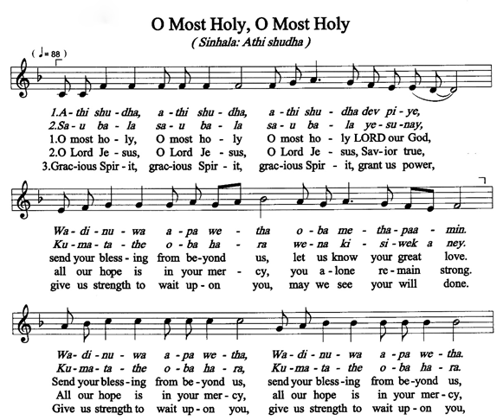
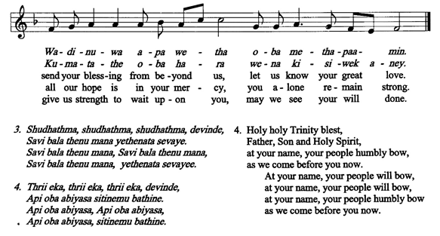

Offertory

Prayer – I

Loving and caring God, you who alone offers speedy succour,
who manifests prompt visitation upon the sick when they are vulnerable,
we pray to you for those who are suffering due to COVID-19.
Deliver them from their infirmities and pain.

You are the only one who enriches us,
with your deep ocean of compassion and solace when we are in grave trouble.
We entreat you to free your people from all troubles and illnesses.
Merciful Lord, we believe that you are a fountain of healing,
you dispense cures to all in need.

Show us the divine streams of your mercy, and cure all those who are grievously sick.
Look upon our supplications and deliver us from all affliction.
We believe that you are the only sure and secure anchor that we have,
you are our protection.
We come to you with our fervent faith and pray for your grace.

Gracious God, the Master of the universe and Lord of all,
you are the Physician, Redeemer, and Helper of those in pain and illness.
Your servants now seek your ineffable mercy.
We pray to you with ardent faith.

Though we may have stumbled, have pity on us and be merciful.
Free your people from all types of suffering and take away all diseases.
Heal us through your divine grace.

Lord, we pray that you accept our supplications according to your will. Amen.

Prayer – II

Lord, we stand with our sisters and brothers who are suffering from weakness and illness.
We know that by your wounds they are healed.

We pray for the strength to overcome this hardship together as your body;
We pray for the protection of all people who are in the frontline against COVID-19;
We pray for the speedy recovery and healing of those who are fighting off the disease;
We pray for calm, comfort, and rational action in quelling panic and allaying fears;
We pray for solidarity within our global human family in this distressing situation.
Let your peace dwell in us.

In Jesus’ name, we pray. Amen.

Blessings

The people who walked in darkness have seen a great light; those who lived in a land of deep darkness—on them a light has shined. (Isaiah 9:2, NRSV)

May God’s healing hand rest upon us;
May God’s life-giving powers flow into every cell of our body and into the depths of our soul,
cleansing, purifying, restoring us to wholeness and strength in God’s peace.

Amen.

